Name: ____________________________________ Period: ______

Drawing Challenges

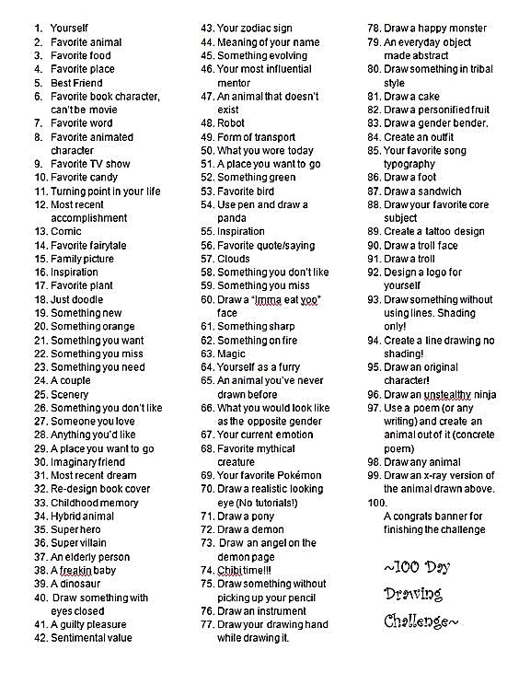

Whenever you have free time in art class, you should work on your drawing challenges on the attached pages. Your drawings don’t have to be super-realistic or detailed, but you should label each drawing with the number and the challenge. You should draw a border around each completed challenge and you can put several drawings on one page.

Cross out each challenge on this page when you finish it, and you do not have to draw the challenges in order.