[[](https://www.facebook.com/ArchiDesiign/?ref=nf&__tn__=%3c-R&eid=ARDp_9bYbXO8hGZIaRfM6x0zLP7Gr7XC2eZRkAgodZLnaf-uZOPCPjqqoCQacf6yOPDCpnqX318jxrqN&hc_ref=ARTO05s0Pu60jcBEFMeGrYHhsAHn5jyqX4xc1Jn2OhTP3HuMpziEyATRufsA8dfR4w8&__xts__%5b0%5d=68.ARBx0_Nj6j8cNUwdkoyZOf_SkogdBsKWTqKJVquPsQw-O2rdmCRAMXujyW8qhYWLxCUZ7tWRw_DtLOLukEQBPAPW1_YLlHJ2SR3N8wsV8qPkLUpvCxfDi2UdAmBjix5gB0l5ps7iuXLUdkPydcvRuF-rPOutuGcDIW5oehCxXe2vf_urr7X7A-we9r3cMcuziZB6Zp-vi4YBZuhMoGsWRrClLE3RNhec8G-d9-t8kmI2bVV7Kr4_zJNTktBAumulcGq2Y_xtbV_3oqBsOnOxBPDcE1Yrd0jl8zLpcqRgefDzo55eqOcp39Vj566_rRIHcurJ1W-_RdRkje7WlfM6UZ9OjA)](https://www.facebook.com/ArchiDesiign/?ref=nf&__tn__=%3C-R&eid=ARDp_9bYbXO8hGZIaRfM6x0zLP7Gr7XC2eZRkAgodZLnaf-uZOPCPjqqoCQacf6yOPDCpnqX318jxrqN&hc_ref=ARTO05s0Pu60jcBEFMeGrYHhsAHn5jyqX4xc1Jn2OhTP3HuMpziEyATRufsA8dfR4w8&__xts__%5B0%5D=68.ARBx0_Nj6j8cNUwdkoyZOf_SkogdBsKWTqKJVquPsQw-O2rdmCRAMXujyW8qhYWLxCUZ7tWRw_DtLOLukEQBPAPW1_YLlHJ2SR3N8wsV8qPkLUpvCxfDi2UdAmBjix5gB0l5ps7iuXLUdkPydcvRuF-rPOutuGcDIW5oehCxXe2vf_urr7X7A-we9r3cMcuziZB6Zp-vi4YBZuhMoGsWRrClLE3RNhec8G-d9-t8kmI2bVV7Kr4_zJNTktBAumulcGq2Y_xtbV_3oqBsOnOxBPDcE1Yrd0jl8zLpcqRgefDzo55eqOcp39Vj566_rRIHcurJ1W-_RdRkje7WlfM6UZ9OjA" \t ")

[**Architecture & Design**](https://www.facebook.com/ArchiDesiign/?__tn__=kC-R&eid=ARDKDAdOlPWast0yonTYCpXGxXOJeBa0pRyo4Xz7rktyZ4x5I_q4fuSWcrVHTeyibRStnJellqMY3Z97&hc_ref=ARS8imOd0yEl5NL0xodO6alriPhkFl2ynCkUjVYPaM-BeDHq0EpnT9M46p8oSZjEDsM&fref=nf&__xts__%5B0%5D=68.ARBx0_Nj6j8cNUwdkoyZOf_SkogdBsKWTqKJVquPsQw-O2rdmCRAMXujyW8qhYWLxCUZ7tWRw_DtLOLukEQBPAPW1_YLlHJ2SR3N8wsV8qPkLUpvCxfDi2UdAmBjix5gB0l5ps7iuXLUdkPydcvRuF-rPOutuGcDIW5oehCxXe2vf_urr7X7A-we9r3cMcuziZB6Zp-vi4YBZuhMoGsWRrClLE3RNhec8G-d9-t8kmI2bVV7Kr4_zJNTktBAumulcGq2Y_xtbV_3oqBsOnOxBPDcE1Yrd0jl8zLpcqRgefDzo55eqOcp39Vj566_rRIHcurJ1W-_RdRkje7WlfM6UZ9OjA)

[March 26, 2019](https://www.facebook.com/ArchiDesiign/posts/1744471929041388?__xts__%5B0%5D=68.ARBx0_Nj6j8cNUwdkoyZOf_SkogdBsKWTqKJVquPsQw-O2rdmCRAMXujyW8qhYWLxCUZ7tWRw_DtLOLukEQBPAPW1_YLlHJ2SR3N8wsV8qPkLUpvCxfDi2UdAmBjix5gB0l5ps7iuXLUdkPydcvRuF-rPOutuGcDIW5oehCxXe2vf_urr7X7A-we9r3cMcuziZB6Zp-vi4YBZuhMoGsWRrClLE3RNhec8G-d9-t8kmI2bVV7Kr4_zJNTktBAumulcGq2Y_xtbV_3oqBsOnOxBPDcE1Yrd0jl8zLpcqRgefDzo55eqOcp39Vj566_rRIHcurJ1W-_RdRkje7WlfM6UZ9OjA&__tn__=-R) ·

Mind Blowing Notebook Doodle [#Art](https://www.facebook.com/hashtag/art?source=feed_text&epa=HASHTAG&__xts__%5B0%5D=68.ARBx0_Nj6j8cNUwdkoyZOf_SkogdBsKWTqKJVquPsQw-O2rdmCRAMXujyW8qhYWLxCUZ7tWRw_DtLOLukEQBPAPW1_YLlHJ2SR3N8wsV8qPkLUpvCxfDi2UdAmBjix5gB0l5ps7iuXLUdkPydcvRuF-rPOutuGcDIW5oehCxXe2vf_urr7X7A-we9r3cMcuziZB6Zp-vi4YBZuhMoGsWRrClLE3RNhec8G-d9-t8kmI2bVV7Kr4_zJNTktBAumulcGq2Y_xtbV_3oqBsOnOxBPDcE1Yrd0jl8zLpcqRgefDzo55eqOcp39Vj566_rRIHcurJ1W-_RdRkje7WlfM6UZ9OjA&__tn__=%2ANK-R) 👌👌  
Credits: [Iantha Naicker (Deaf)](https://www.facebook.com/ianthaartlife/?__tn__=K-R&eid=ARDdamAZp0i7Nj2p3ZTRbIm-DAM52GzOtF8S3HsU6XuSv32CqE6u4cMqQBxew5pi3DzlaW2iJsVi40YA&fref=mentions&__xts__%5B0%5D=68.ARBx0_Nj6j8cNUwdkoyZOf_SkogdBsKWTqKJVquPsQw-O2rdmCRAMXujyW8qhYWLxCUZ7tWRw_DtLOLukEQBPAPW1_YLlHJ2SR3N8wsV8qPkLUpvCxfDi2UdAmBjix5gB0l5ps7iuXLUdkPydcvRuF-rPOutuGcDIW5oehCxXe2vf_urr7X7A-we9r3cMcuziZB6Zp-vi4YBZuhMoGsWRrClLE3RNhec8G-d9-t8kmI2bVV7Kr4_zJNTktBAumulcGq2Y_xtbV_3oqBsOnOxBPDcE1Yrd0jl8zLpcqRgefDzo55eqOcp39Vj566_rRIHcurJ1W-_RdRkje7WlfM6UZ9OjA)

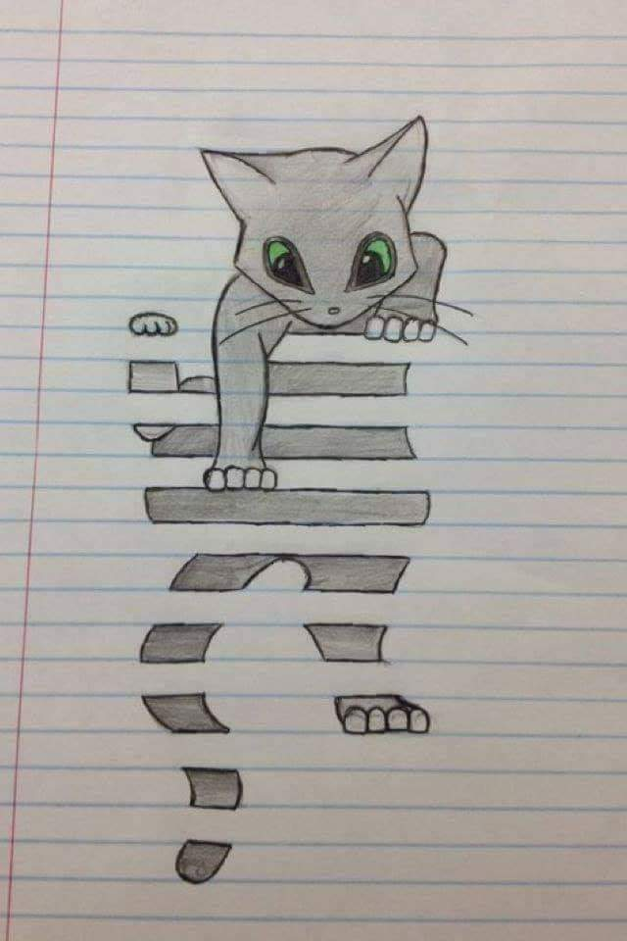

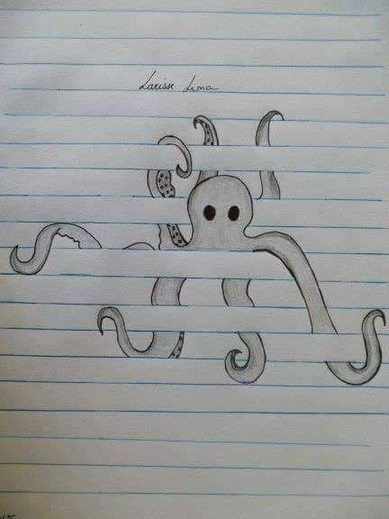



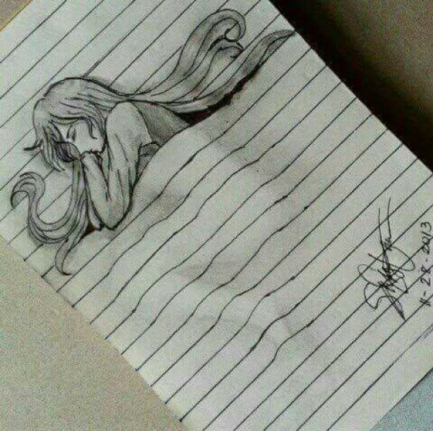

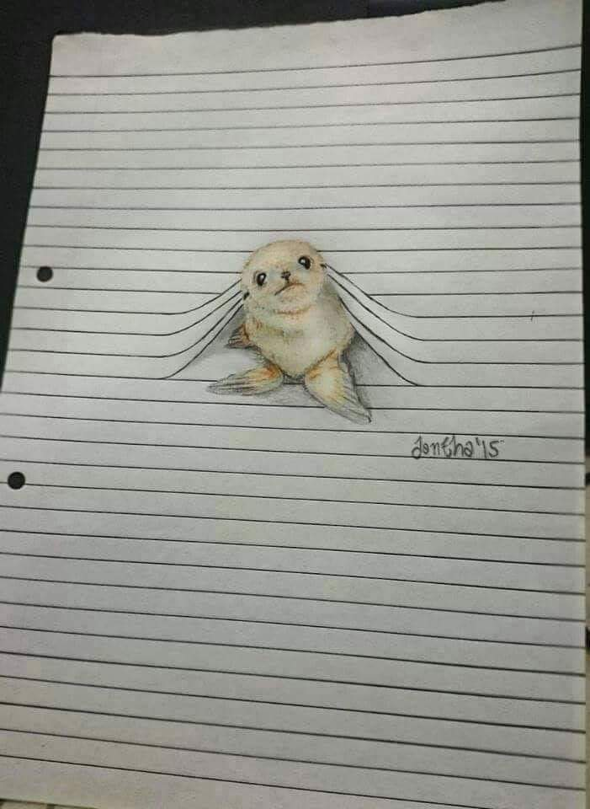



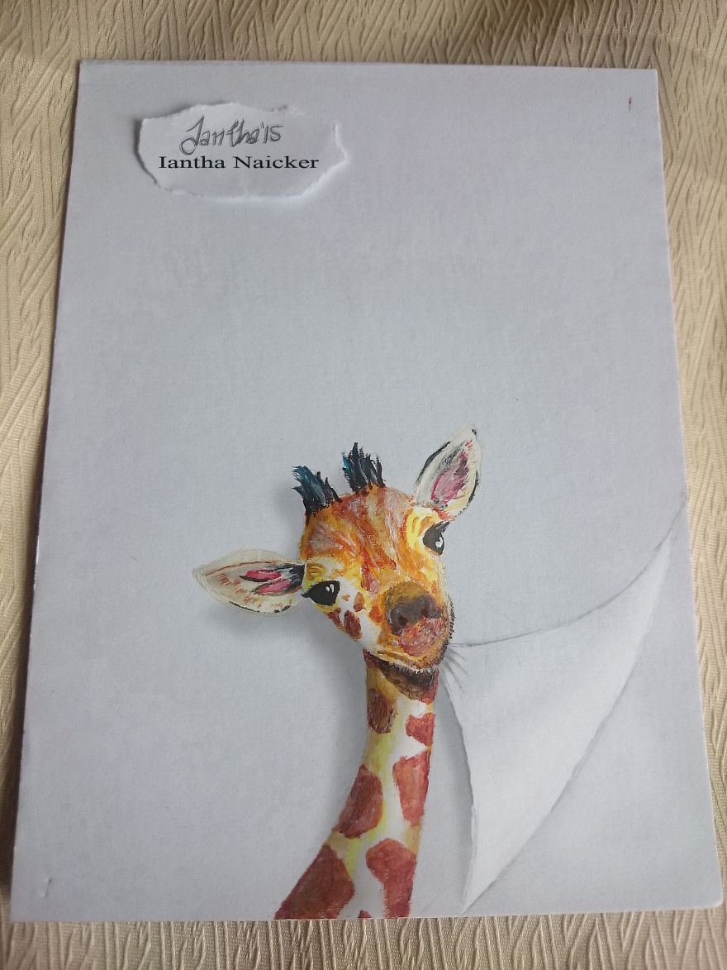

<https://www.boredpanda.com/3d-animal-illustrations-playing-with-paper-iantha-naicker/?utm_source=google&utm_medium=organic&utm_campaign=organic>

