Honors Algebra II Name___________________________

LT 8-1: Characteristics of Polynomials Day 1 Period____

**Using the characteristics that we discussed in class today, fill in the blanks.**

1) An __________________ degree polynomial must have at least one real zero.

2) A polynomial function is written in __________________ __________________ if its terms are written in descending order of exponents from left to right.

3) The __________________ __________________ is the number in front of the term with the highest exponent in the polynomial.

4) A __________________ is a polynomial with one term, a __________________ has two terms, and a __________________ has three terms.

5) It is possible for an __________________ degree polynomial to have no real zeros.

6) The __________________ __________________ __________________ is used to determine the end behavior of the graph of a polynomial function.

**Write each polynomial in standard form and state the degree, type, leading coefficient, and the end behavior. The first example has been done for you.**

|  |  |  |  |  |  |  |
| --- | --- | --- | --- | --- | --- | --- |
|  | **Standard Form** | **Degree** | **Classify by Degree** | **Classify by Number of Terms** | **LC** | **End Behavior** |
| *Example: $y=7-3x$* | $$y=-3x+7$$ | 1 | Linear | Binomial | $$-3$$ | As $x→-∞, y→∞$ As $x→∞, y→-∞$ |
| 7) $f\left(x\right)=2x-x^{3}+8$ |  |  |  |  |  |  |
| 8) $y=3x^{2}+x^{3}-(x^{3}+x^{2})$ |  |  |  |  |  |  |
| 9) $y={\left(2x\right)}^{3}+3x-1$ |  |  |  |  |  |  |
| 10) $f\left(x\right)={\left(x+2\right)}^{2}+3$ |  |  |  |  |  |  |
| 11) $y=\left(2+x\right)\left(2-x\right)-4$ |  |  |  |  |  |  |
| 12) $f\left(x\right)=3{\left(x+1\right)}^{2}-3x^{2}$ |  |  |  |  |  |  |
| 13) $g\left(x\right)=2x-2(x-3)$ |  |  |  |  |  |  |

**Describe the end behavior of the graph of the polynomial function without graphing.**

|  |  |  |
| --- | --- | --- |
| 14) $y=4x-2+5x^{5}$ As $x→-∞, y→_________$ and as $x→∞, y→_________$ | 15) $y=-5x^{3}+2x$ As $x→-∞, y→_________$ and as $x→∞, y→_________$ | 16) $y=-2x-12x^{6}+5$ As $x→-∞, y→_________$ and as $x→∞, y→_________$ |
| 17) $y=6-2x+6x^{2}-12x^{9}$ As $x→-∞, y→_________$ and as $x→∞, y→_________$ | 18) $y=1-x^{6}-1+2x^{6}$ As $x→-∞, y→_________$ and as $x→∞, y→_________$ | 19) $y=x(x-2)(x+3)(-2x-5)$ As $x→-∞, y→_________$ and as $x→∞, y→_________$ |

**Match the polynomial function with its graph without using a graphing calculator.**

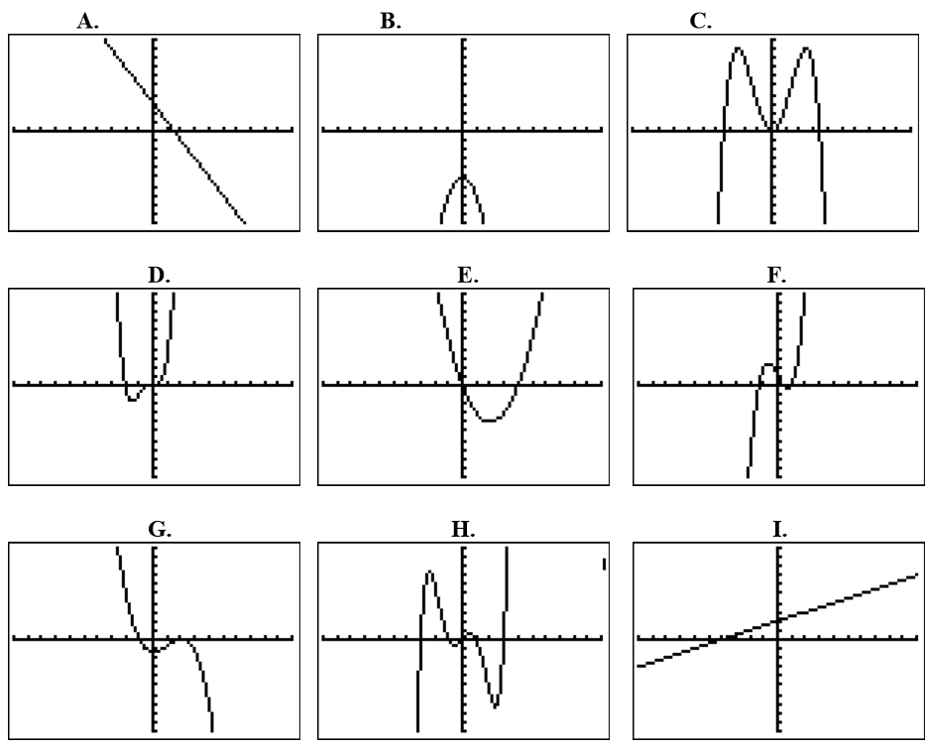

|  |  |  |
| --- | --- | --- |
| ____ 20) $y=x^{2}-4x$ | ____ 21) $y=2x^{3}-3x+1$ | ____ 22) $y=-\frac{1}{3}x^{3}+x^{2}-\frac{4}{3}$ |
| ____ 23) $y=\frac{1}{2}x+2$ | ____ 24) $y=-2x^{2}-5$ | ____ 25) $y=3x^{2}-\frac{1}{4}x^{4}$ |
| ____ 26) $y=3-2x$ | ____ 27) $y=2x^{3}+x^{4}$ | ____ 28) $y=\frac{1}{5}x^{5}-2x^{3}+\frac{9}{5}x$ |