Honors Algebra II Name___________________________

LT 8-1: Characteristics of Polynomials Day 2 Period____

**State the information for the given polynomials. Then, provide a sketch of the function.**

1) *P*1(*x*) = (*x* − 2)(*x* + 5)2 2) *P*2(*x*) = 2(*x* − 2)(*x* + 2)(*x* − 3)

y-intercept: ___________ y-intercept: ___________

x-intercept(s): ________________________ x-intercept(s): ________________________

Degree: _______ Bounce Points: __________ Degree: _______ Bounce Points: __________

End Behavior/Orientation: ___________ End Behavior/Orientation: ___________

Number Line: Number Line:

___________________________________ ___________________________________

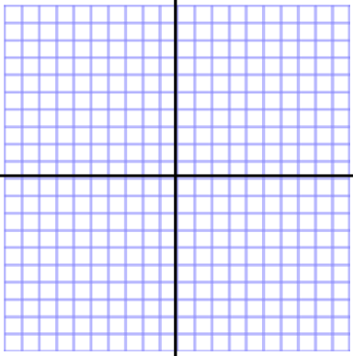

3) *P*3(*x*) = −2(*x* + 3)2(*x* + 1)(*x* − 1)(*x* − 5) 4) *P*4(*x*) = −0.1*x*(*x* + 4)3

y-intercept: ___________ y-intercept: ___________

x-intercept(s): ________________________ x-intercept(s): ________________________

Degree: _______ Bounce Points: __________ Degree: _______ Bounce Points: __________

End Behavior/Orientation: ___________ End Behavior/Orientation: ___________

Number Line: Number Line:

___________________________________ ___________________________________



5) *P*5(*x*) = *x*4 − 9*x*2 6) *P*6(*x*) = 0.2*x*(*x* + 1)(*x* − 3)(*x* + 4)

y-intercept: ___________ y-intercept: ___________

x-intercept(s): ________________________ x-intercept(s): ________________________

Degree: _______ Degree: _______

Bounce Points: _______________________ Bounce Points: _______________________

End Behavior/Orientation: ___________ End Behavior/Orientation: ___________

Number Line: Number Line:

___________________________________ ___________________________________

 

7) Without using a calculator, sketch rough graphs of the following functions.

a) *P*(*x*) = −*x*(*x* + 1)(*x* − 3) b) *P(x)* = (*x −* 1)2(*x +* 2)(*x −* 4) c) *P*(*x*) = (*x* + 2)3(*x* − 4)

