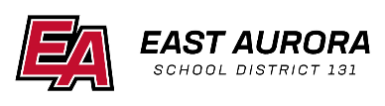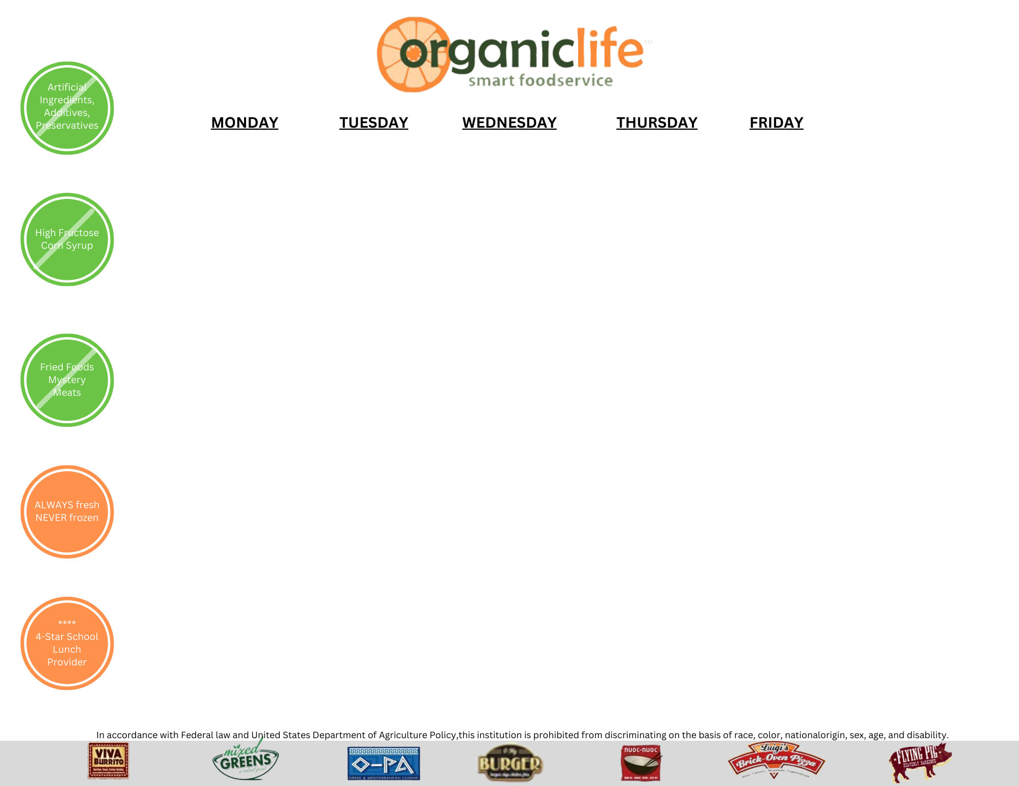

|  |  |  |  |  |
| --- | --- | --- | --- | --- |
| **Monday** | **Tuesday** | **Wednesday** | **Thursday** | **Friday** |
|  |  |  |  | 1  No School |
| 4  Mac And Cheese  Seasonal Farm Veggies  Fruit of the Day  Milk Choice | 5  Beef Nachos  Seasonal Farm Veggies  Fruit of the Day  Milk Choice | 6  Spicy Chicken Tenders  Seasonal Farm Veggies  Fruit of the Day  Milk Choice | 7  Fajita Quesadilla  Seasonal Veggies  Fruit of the Day  Milk Choice | 8  Half Day |
| 11  Mini Cheese Calzones  Seasonal Farm Veggies  Fruit of the Day  Milk Choice | 12  BBQ Pulled Pork Sandwich  Seasonal Farm Veggies  Fruit of the Day  Choice of Milk | 13  Bosco Sticks  Seasonal Farm Veggies  Fruit of the Day  Milk Choice | 14  Chicken Nachos  Seasonal Farm Veggies  Fruit of the Day  Milk Choice | 15  Toasted Ham and Cheese Sandwich  Seasonal Farm Veggies  Fruit of the Day  Milk Choice |
| 18  Chicken Nuggets  Seasonal Farm Veggies  Fruit of the Day  Milk Choice | 19  Beef Taco Tuesday  Seasonal Farm Veggies  Fruit of the Day  Milk Choice | 20  Spicy Chicken Tenders  Seasonal Farm Veggies  Fruit of the Day  Milk Choice | 21  Cheese Quesadilla  Seasonal Farm Veggies  Fruit of the Day  Milk Choice | 22  Cheese Filled Breadsticks  Seasonal Farm Veggies  Fruit of the Day  Choice of Milk |
| 25  Spring Break | 26  Spring Break | 27  Spring Break | 28  Spring Break | 29  Spring Break |

**March 2024 Lunch Menu Cowherd**

# **Daily Middle School Lunch Choices:**

**Pizza of the Day**

**Spicy Chicken Sandwich**

**Cheeseburger**

**Sun Butter and Jelly Sandwich**

## Milk Choices:

1% White

Or

Fat Free Chocolate

### **Menu Subject to Change**