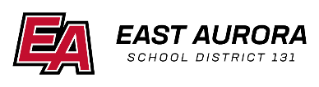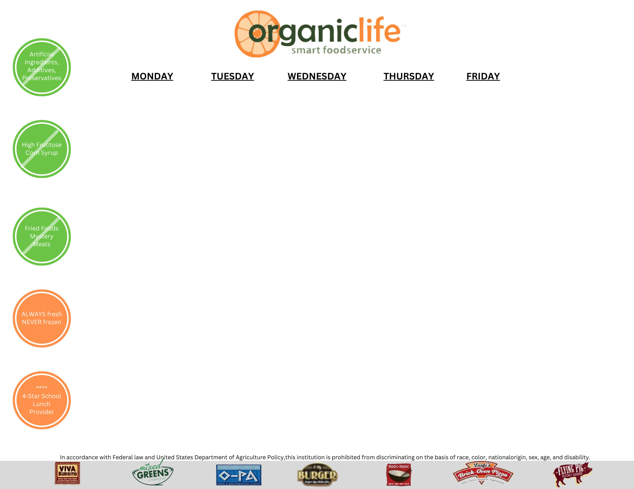

|  |  |  |  |  |
| --- | --- | --- | --- | --- |
| **Monday** | **Tuesday** | **Wednesday** | **Thursday** | **Friday** |
|  |  |  |  | 1  No School |
| 4  Confetti Pancakes  Fruit of the Day  Milk Choice | 5  Cinnamon Toast Crunch Warm Bar  Fruit of the Day  Milk Choice | 6  Sausage Breakfast Pizza  Fruit of the Day  Milk Choice | 7  Whole Grain Pop Tart  Fruit of the Day  Milk Choice | 8  Eggs and Sausage Links  Fruit of the Day  Milk Choice |
| 11  Muffin with String Cheese  Fruit of the Day  Milk Choice | 12  Apple Frudel Bar  Fruit of the Day  Milk Choice | 13  Whole Grain Glazed Buns  Fruit of the Day  Milk Choice | 14  Chocolate and Oatmeal Bar  Fruit of the Day  Milk Choice | 15  Mini Maple Waffles  Fruit of the Day  Milk Choice |
| 18  Strawberry Cream Cheese Bagel  Fruit of the Day  Milk Choice | 19  Cinnamon Toast Crunch Warm Bar  Fruit of the Day  Milk Choice | 20  Mini Pancakes  Fruit of the Day  Milk Choice | 21  Eggs and Sausage Links  Fruit of the Day  Milk Choice | 22  Whole Grain French Toast  Fruit of the Day  Milk Choice |
| 25  Spring Break | 26  Spring Break | 27  Spring Break | 28  Spring Break | 29  Spring Break |

**March 2024 Breakfast Menu**

# **Daily Breakfast Choice:**

**Bowl of Cereal**

**Or**

**Cereal Bar**

## Milk Choices:

1% White

Or

Fat Free Chocolate

### **Menu Subject to Change**