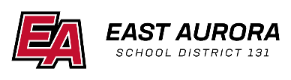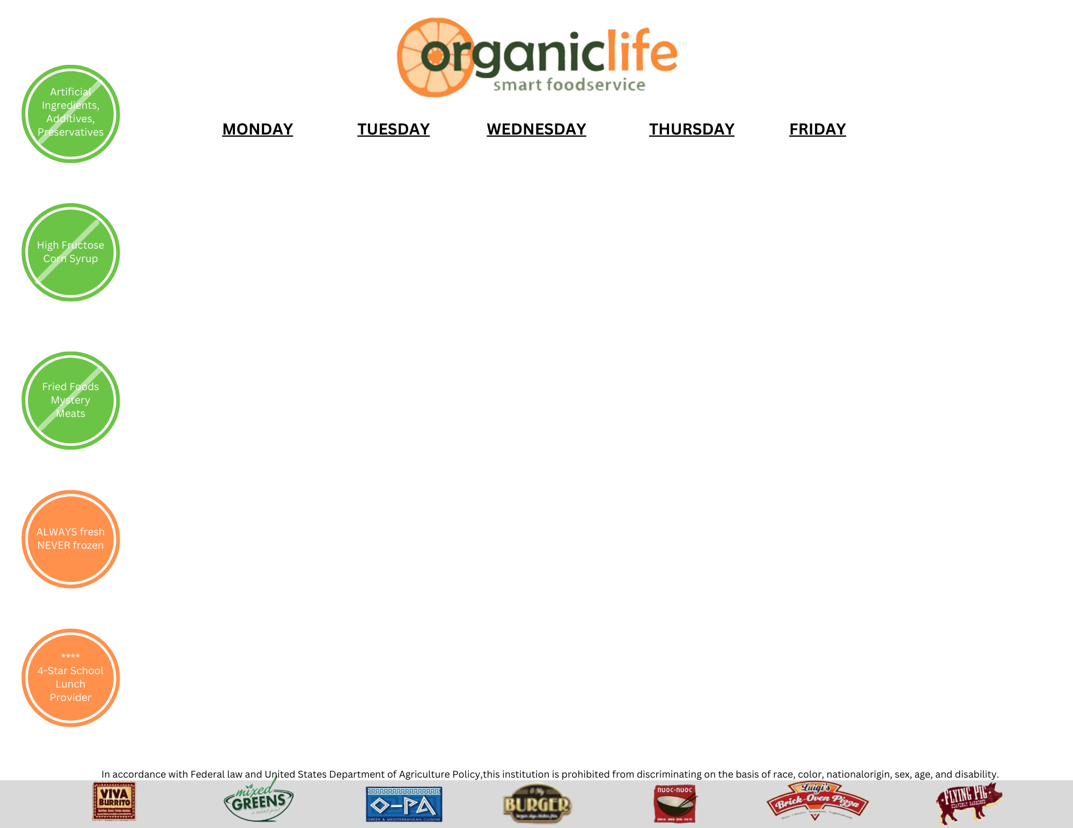

|  |  |  |  |  |
| --- | --- | --- | --- | --- |
| **Monday** | **Tuesday** | **Wednesday** | **Thursday** | **Friday** |
|  |  |  |  | 1  No School |
| 4  Chicken Nuggets  Seasonal Farm Veggies  Fruit of the Day  Milk Choice | 5  Hot Dog  Seasonal Farm Veggies  Fruit of the Day  Milk Choice | 6  Chicken Tenders  Seasonal Farm Veggies  Fruit of the Day  Milk Choice | 7  Cheese Pizza  Seasonal Veggies  Fruit of the Day  Milk Choice | 8  Half Day |
| 11  Mini Cheese Calzones  Seasonal Farm Veggies  Fruit of the Day  Choice of Milk | 12  Corn Dogs  Seasonal Farm Veggies  Fruit of the Day  Milk Choice | 13  Bosco Sticks  Seasonal Farm Veggies  Fruit of the Day  Milk Choice | 14  Chicken Patty Sandwich  Seasonal Farm Veggies  Fruit of the Day  Milk Choice | 15  Sun Butter and Jelly Sandwich  Seasonal Farm Veggies  Fruit of the Day  Milk Choice |
| 18  Chicken Nuggets  Seasonal Farm Veggies  Fruit of the Day  Milk Choice | 19  Beef Taco Tuesday  Seasonal Farm Veggies  Fruit of the Day  Milk Choice | 20  Hamburger  Seasonal Farm Veggies  Fruit of the Day  Milk Choice | 21  Cheese Quesadilla  Seasonal Farm Veggies  Fruit of the Day  Milk Choice | 22  Cheese Filled Breadsticks  Seasonal Farm Veggies  Fruit of the Day  Milk Choice |
| 25  Spring Break | 26  Spring Break | 27  Spring Break | 28  Spring Break | 29  Spring Break |

# **Daily Lunch Cold Choice:**

**Sun Butter and Jelly Sandwich**

## Milk Choices

1% White

Or

Fat Free Chocolate

### **Menu Subject to Change**

**March 2024 Lunch**

**Pre-K Menu**