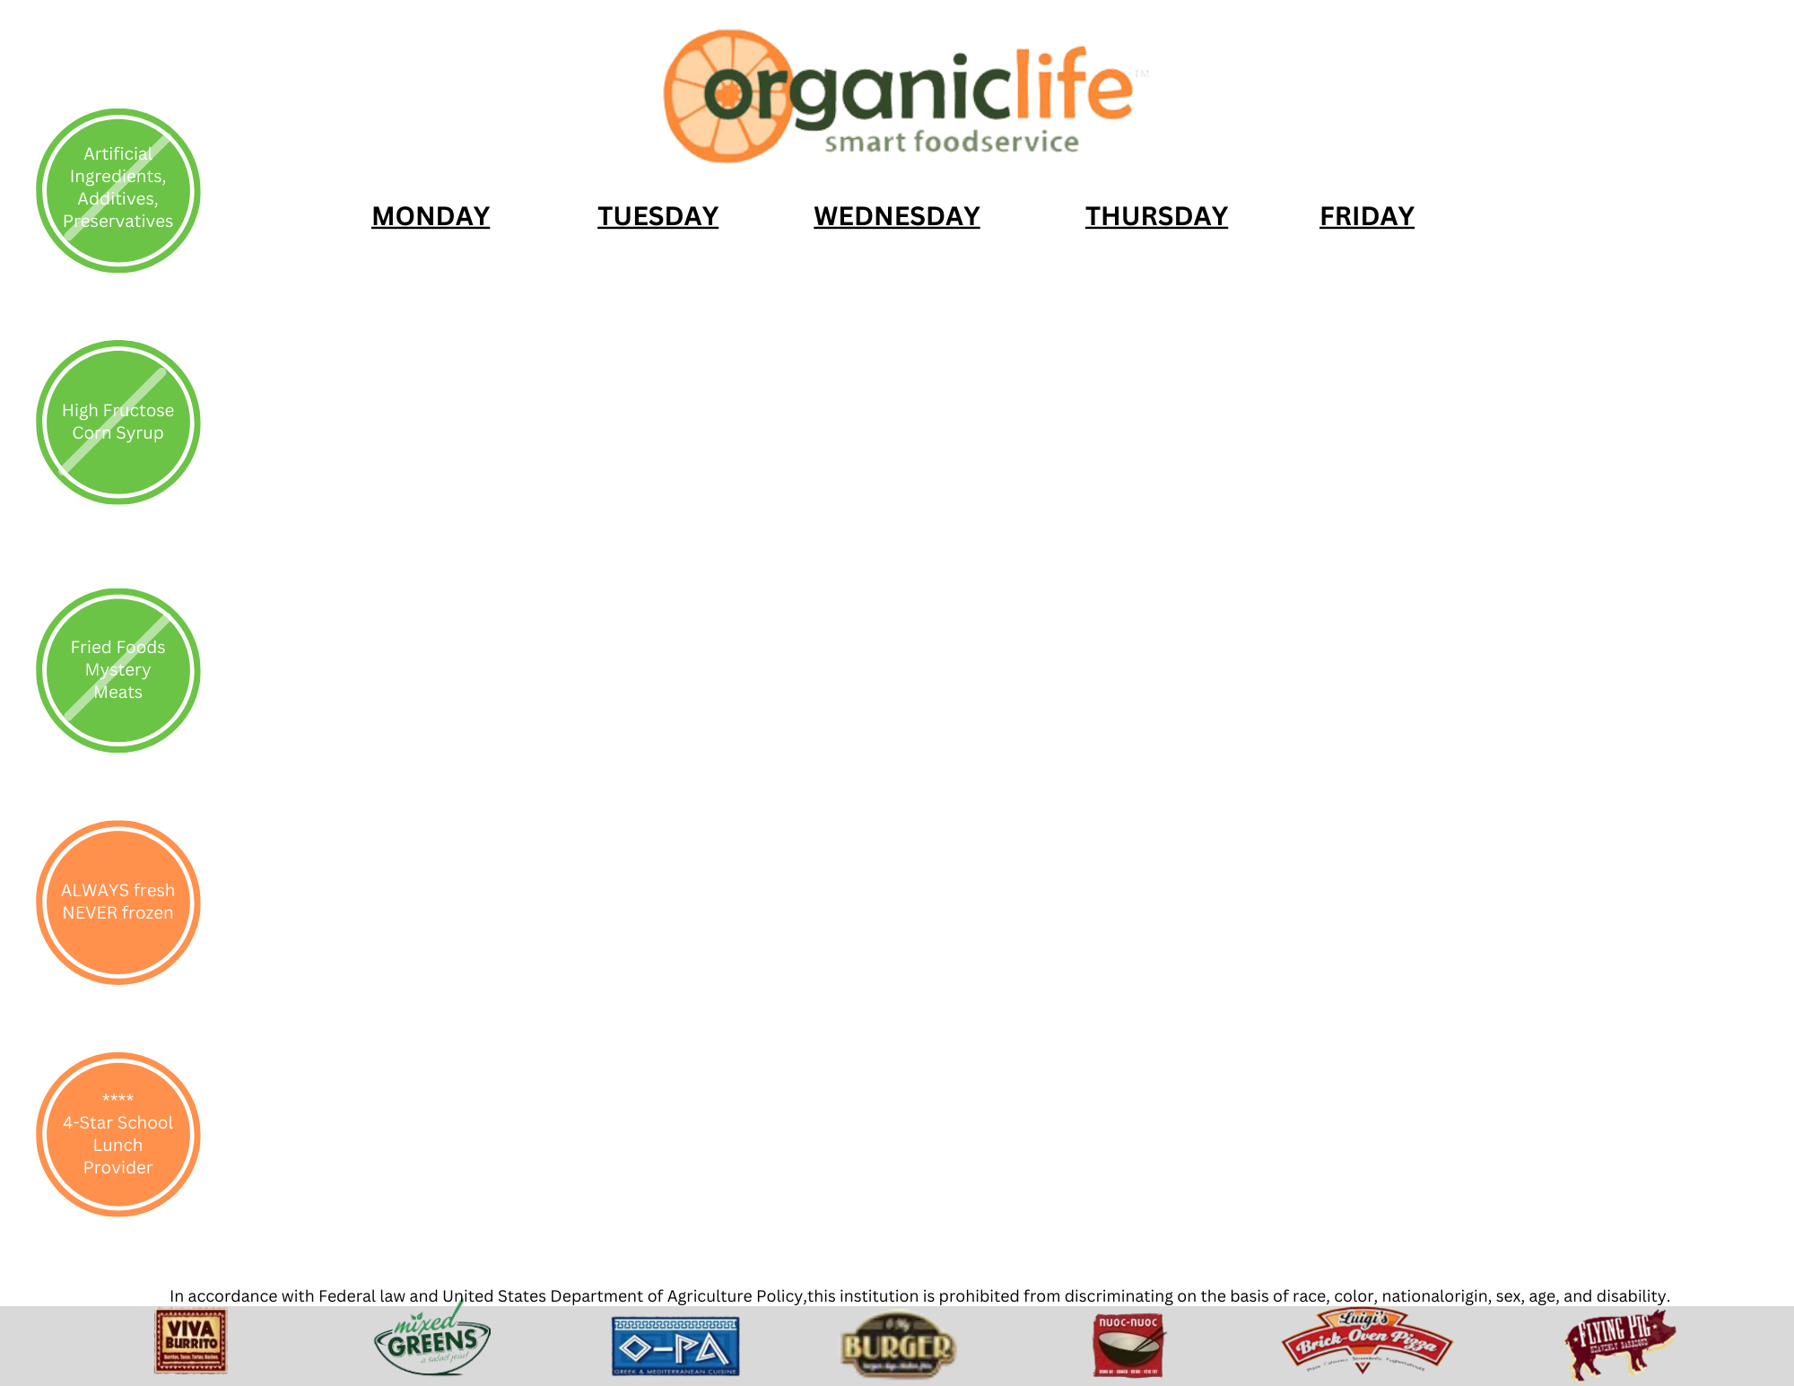

|  |  |  |  |  |
| --- | --- | --- | --- | --- |
| **Monday** | **Tuesday** | **Wednesday** | **Thursday** | **Friday** |
|  |  |  |  | 1  No School |
| 4  Soft Carrots with Ranch Graham Crackers | 5  Whole Grain Animal Crackers  String Cheese | 6  Whole Grain Goldfish ¼ Cup Yogurt | 7  Cauliflower Bites with Ranch  100% Juice 6 oz | 8  Craisins  ¼ Cup Yogurt |
| 11  Banana Muffin  String Cheese | 12  Applesauce Cup  1% White | 13  Broccoli with Ranch  Graham Crackers | 14  Soft Carrots with Ranch Graham Crackers | 15  Whole Grain Goldfish  ¼ Cup Yogurt |
| 18  Cucumber Slices with Graham Crackers | 19  Craisins  ¼ Cup Yogurt | 20  Whole Grain Pretzels  100% Juice 6 oz | 21  Whole Grain Goldfish ¼ Cup Yogurt | 22  Soft Carrots with Ranch Graham Crackers |
| 25  Spring Break | 26  Spring Break | 27  Spring Break | 28  Spring Break | 29  Spring Break |

### **Menu Subject to Change**

**March 2024 Snack**

**Pre-K Menu**